**User-User Collaborative Filtering**

**Introduction:**

Collaborative Filtering is a popular recommendation algorithm whose predictions are based on the ratings of other users in the system. It is assumed that if users agree about the relevance of some items than they will likely agree about other items.

**Algorithm:**

1. Weight all users with respect to similarity with the active user whose rating needs to be predicted.
2. Select a subset of users to use as a set of predictors for a specific item.
3. Method 1 – set a threshold for similarity
4. Method 2 – k nearest neighbours
5. Normalize ratings and calculate the rating of active user’s item using the weighted combination of the selected users.

**My Implementation:**

1. Compute the similarity weight between user and neighbor for a selected item using Constrained Pearson’s correlation.

Wa,u is the similarity weight between active user and neighbor u.

rz = 3, fixed on 5-point scale. It is neutral (neither dislike nor like)

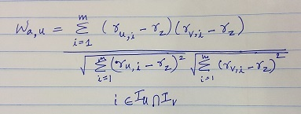

1. Set a threshold and select only valid neighbors i.e. select neighbors with similarity weight greater than 0.1
2. Calculate the predicted rating for the active user for unrated item using the given formula

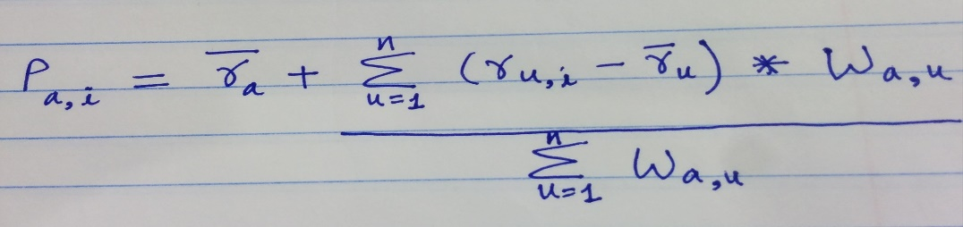

Here, Pa,i is the prediction of active user a for an item i ,

n is the number of neighbours, Wa,u  is the weight similarity

**Implementation Issues:**

1. Computation can be bottleneck i.e. given m users and n items, all pairwise correlations is O(m2n).
2. Selecting neighbors can affect the rating prediction and the neighbors coverage i.e. if threshold not set properly or less neighbors selected then it can increase error rate or decrease the neighbor coverage

**References:**

[1] J.L. Herlocker, J.A. Konstan, J.R.A. Borchers, and J. Riedl, An algorithmic framework for performing collaborative filtering, *Proc. International on ACM SIGIR Research and Development in Information Retrieval*, (SIGIR98) 1998

[2] Jonathan L. Herlocker, Joseph A. Konstan, and John Riedl, Explaining Collaborative Filtering Recommendations